Transformer Voltage Converter

Introduction
This is the voltage converter that I made:

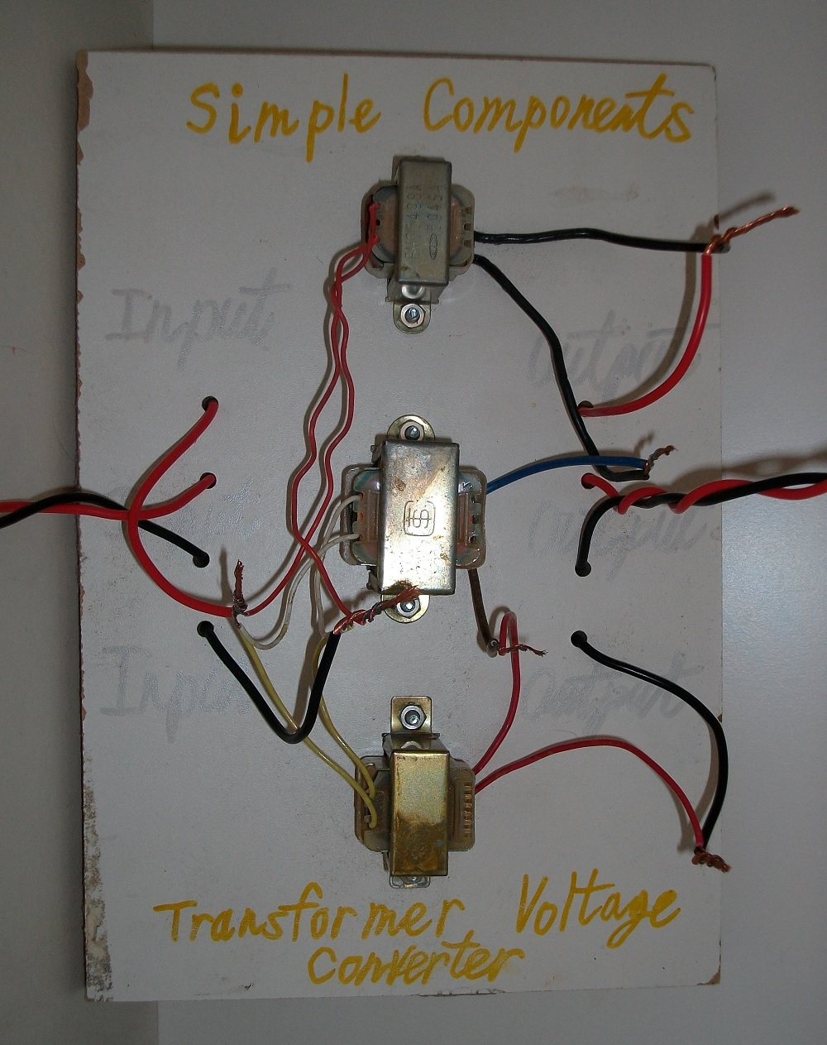
Figure 1: Transformer Voltage Converter.

This converter amplifies the input AC (alternative current) voltage.

Step 1: Design the Circuit

I have drawn the circuit in PSpice simulations software student edition version 9.1:
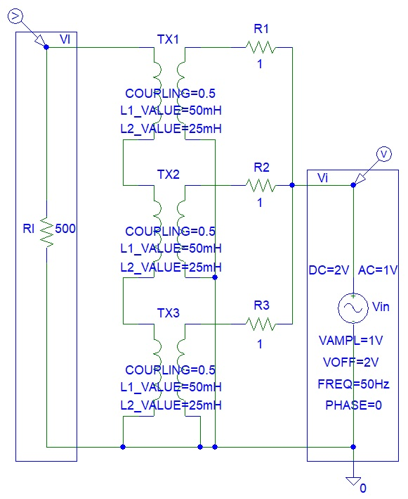
Figure 2: Circuit Design.

I connected resistors in series with transformer inputs to avoid simulations errors. Those errors occur because transformer coil resistance is zero in DC steady state, thus resulting infinite current (ohm’s law).

The coupling is equal to [1]:

$Coupling=\frac{N_{2}}{N_{1}}=\frac{V_{o}}{V_{in}}$
(Where: $N_{2}=$ Number of turns in output coil,
$N_{1}=$ Number of turns in input coil
$V_{o}=$ Output voltage (V)
$V_{in}=$ Input voltage (V))

The left coil is usually the “input” and the right coil is usually the output. However, PSpice transformers simulation models are designed for step down transformers that reduce the voltage (eg. transformer power supply - 220 V AC mains to 12 V DC). The coupling ratio in the old PSpice software cannot be above 1. Thus connected the transformers in reverse (switched input and output) to step up the voltage instead of step down the voltage.

If we ignore mutual inductances of transformer than we can assume that the output coil has twice the inductance of the input coil due to double the number of turns when compared to input coil (refer to inductance of solenoid in [2]).

Step 2: Simulations

Simulations show that the circuit is amplifying the input voltage:

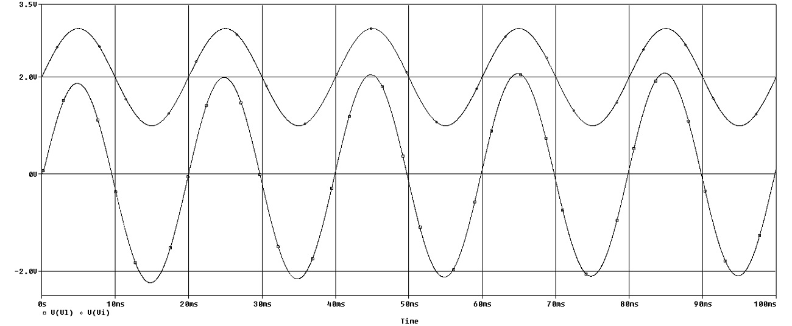
Figure 3: Transient simulations.

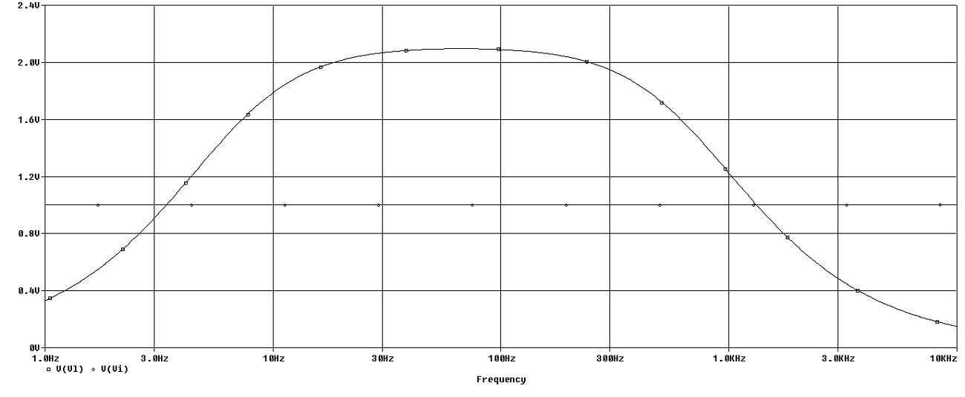
Figure 4: Frequency Spectrum simulations.

Step 3: Make the Circuit

I used an electric drill to drill holes in the wooden panel and attached three transformers:

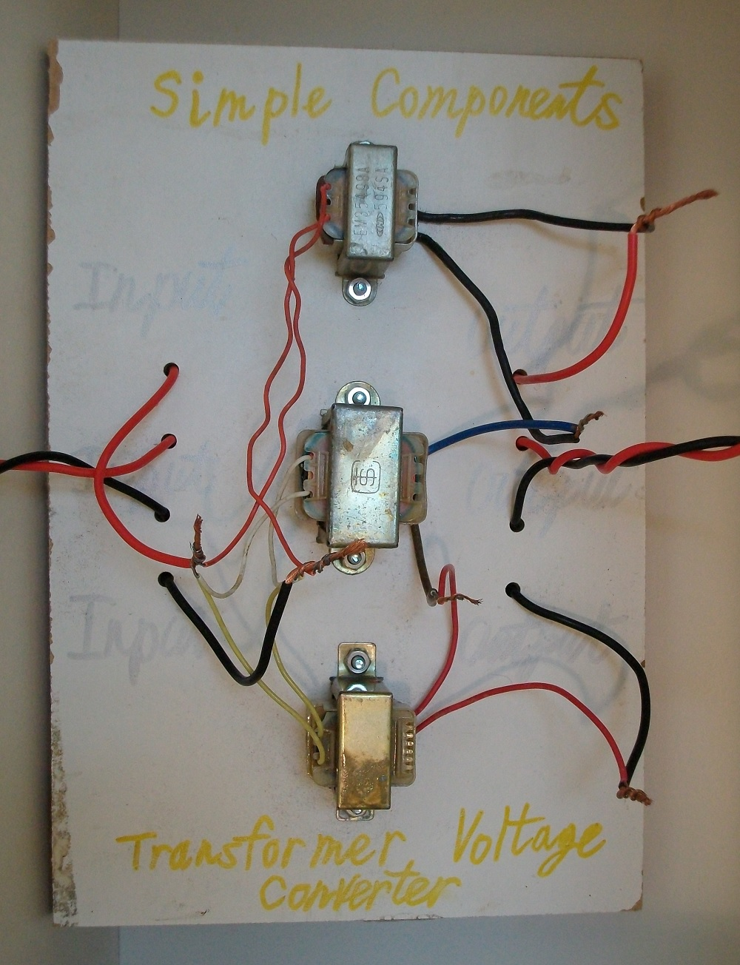
Figure 5: Make the Circuit.

If you are making this circuit then you have to consider the polarity of the transformer inputs and the transformer outputs. An inverted signal (switched polarity) is usually 180 degrees out of phase. Correct polarity will ensure that all three output signals are in phase. Otherwise negative signals will cancel the positive signals.

Step 4: Testing

I used Instrustar USB oscilloscope to acquire and record input and output signals:

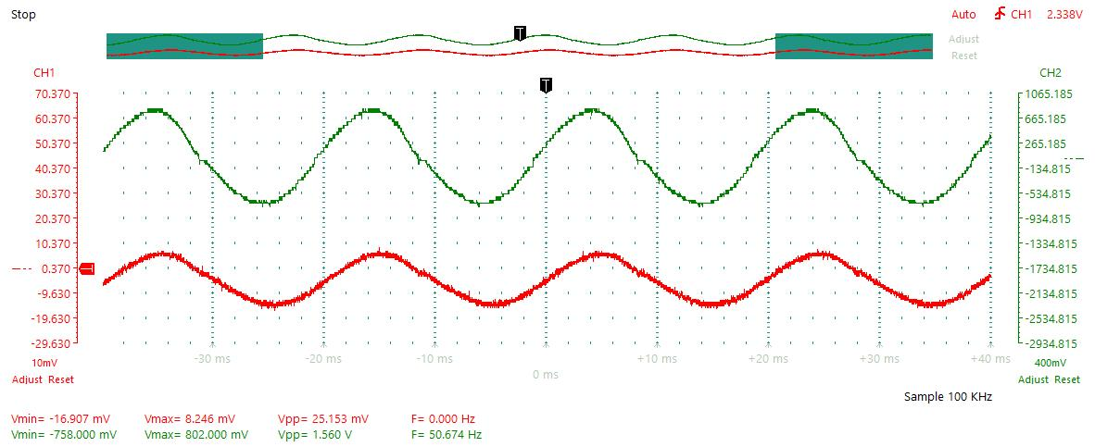
Figure 6: Testing 50 Hz.

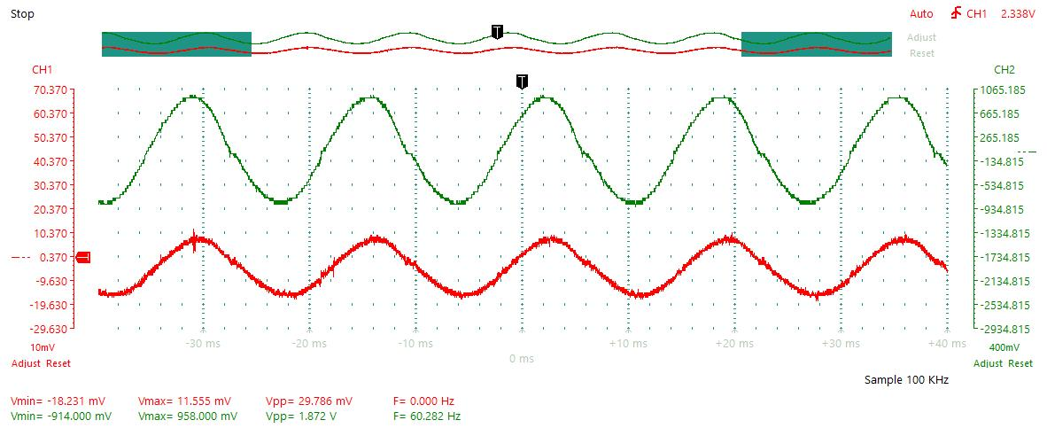
Figure 7: Testing 60 Hz.

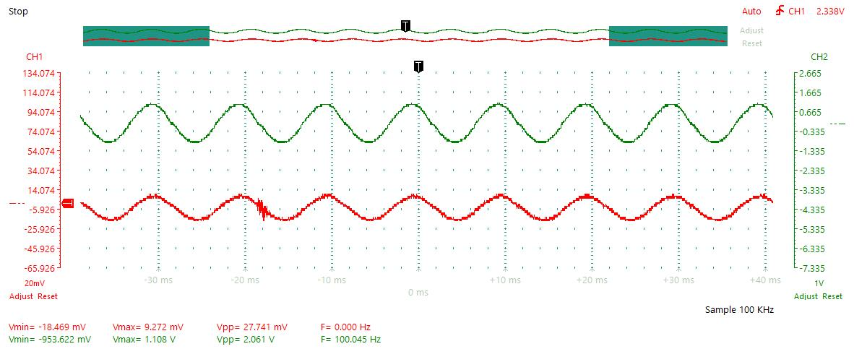
Figure 8: Testing 100 Hz.

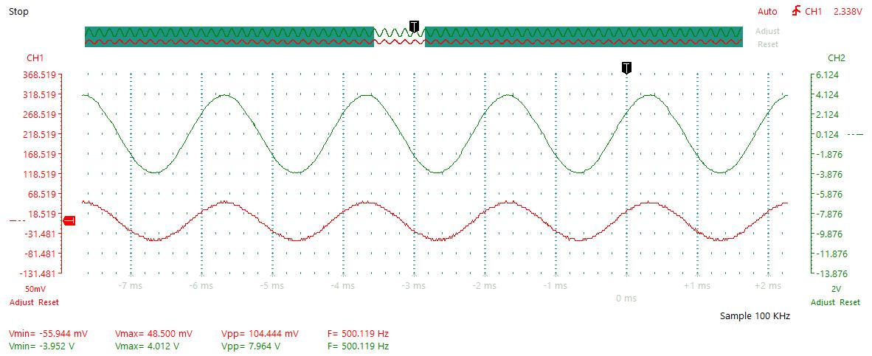
Figure 9: Testing 500 Hz.

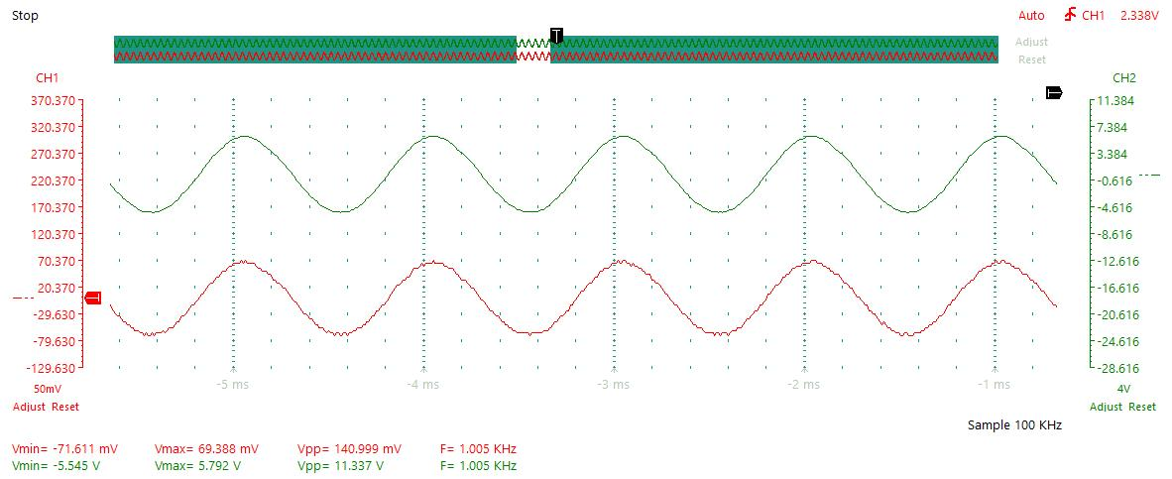
Figure 10: Testing 1 kHz.

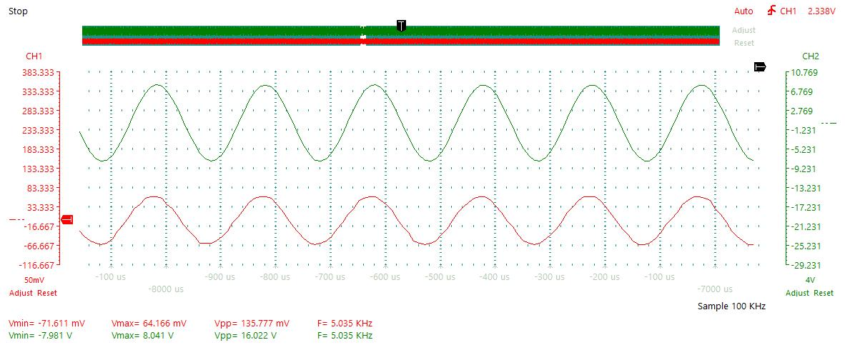
Figure 11: Testing 5 kHz.

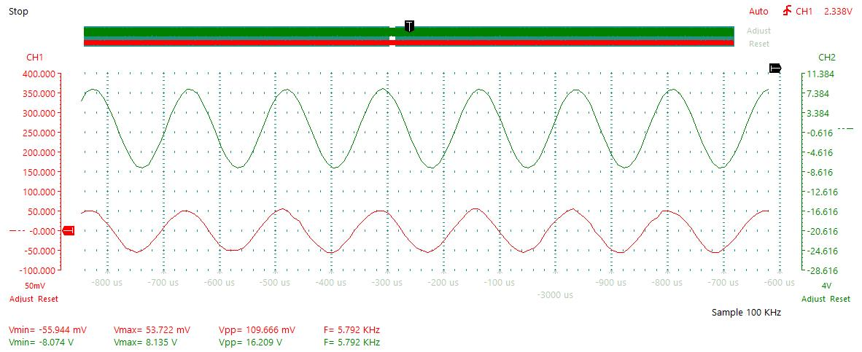
Figure 12: Testing 5.7 kHz.

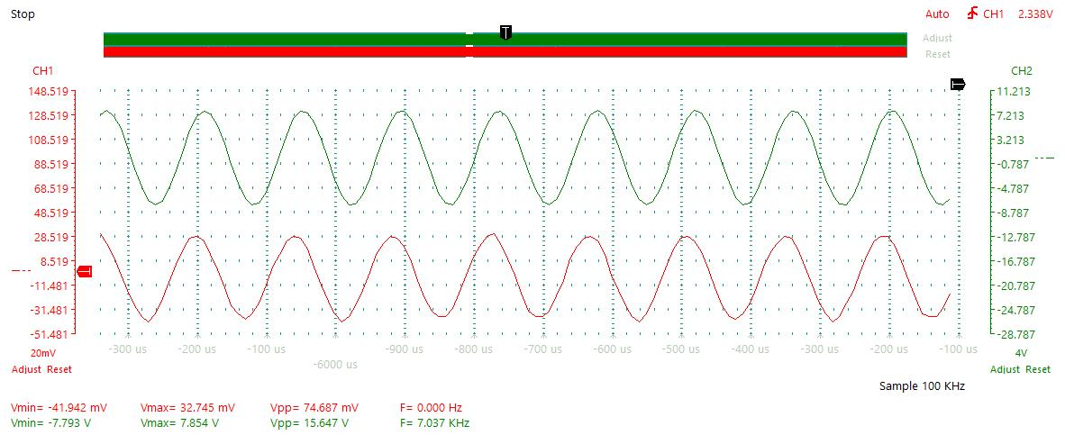
Figure 13: Testing 7 kHz.

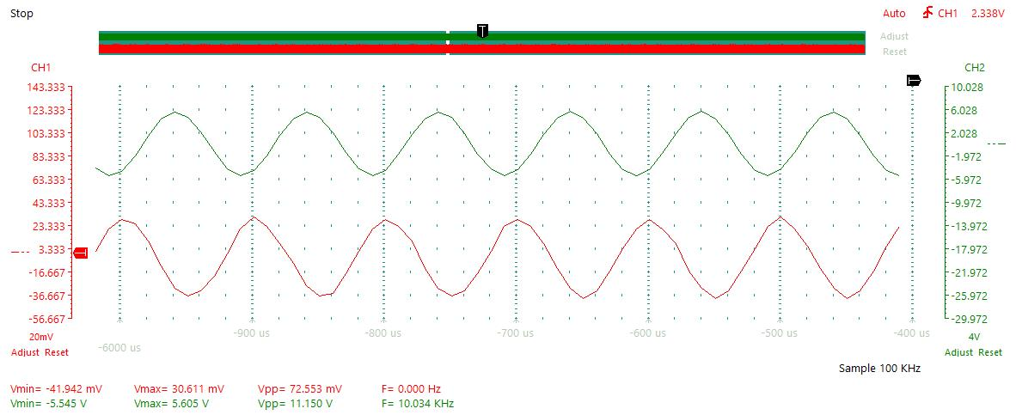
Figure 14: Testing 10 kHz.

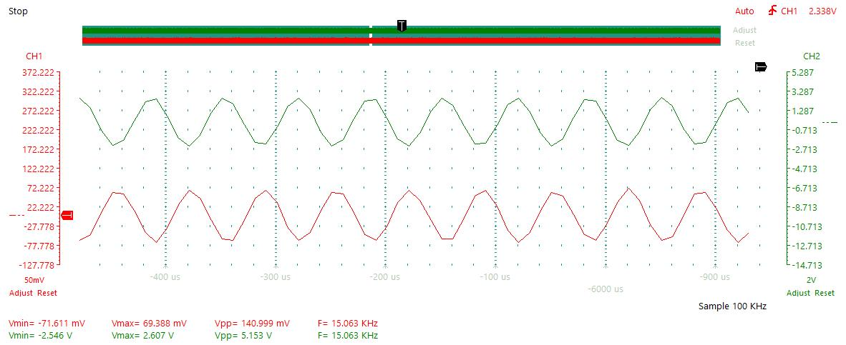
Figure 15: Testing 15 kHz.

Conclusion

Testing showed that the optimum input frequnecy is 5.7 kHz. This frequency results in maximum voltage gain. Although the recycled transformers that I used appeared to be mains transformers (that work with 50 Hz or 60 Hz frequencies), the transformer gain was low at very those low frequencies (50 Hz). Also, the transformer gain would begin drop at frequencies above 10 kHz. This is similar to what was predicted in the simulations.

References

- https://en.wikipedia.org/wiki/Transformer
- https://en.wikipedia.org/wiki/Inductance

